## [Problem](https://docs.python.org/2/library/calendar.html" \l "module-calendar)

The calendar module allows you to output calendars and provides additional useful functions for them.

[class calendar.TextCalendar([firstweekday])](https://docs.python.org/2/library/calendar.html#calendar.TextCalendar)

This class can be used to generate plain text calendars.

**Sample Code**

>>> import calendar

>>>

>>> print calendar.TextCalendar(firstweekday=6).formatyear(2015)

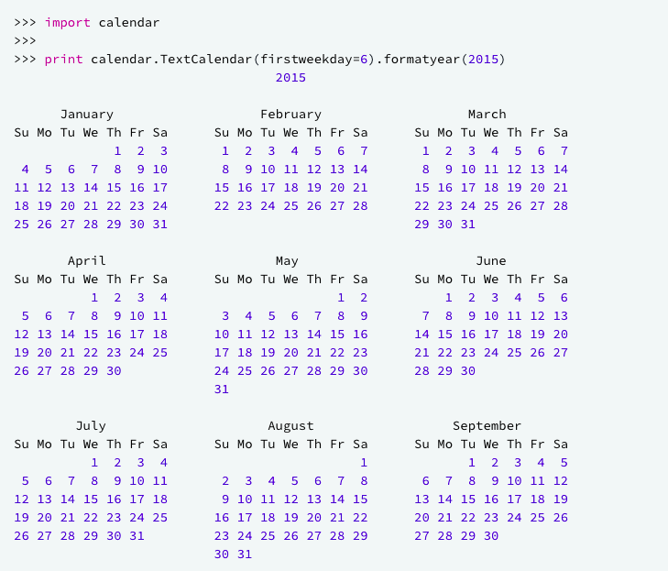

To learn more about different calendar functions, [click here](https://docs.python.org/2/library/calendar.html#calendar.setfirstweekday).

**Task**

You are given a date. Your task is to find what the *day* is on that date.

**Input Format**

A single line of input containing the space separated month, day and year, respectively, in    format.

**Constraints**

* 2000 < year < 3000

**Output Format**

Output the correct day in capital letters.

**Sample Input**

08 05 2015

**Sample Output**

WEDNESDAY

**Explanation**

The day on August 5th 2015 was WEDNESDAY.

## Solution

# Enter your code here. Read input from STDIN. Print output to STDOUT

import calendar

date = input()

month = date[:2]

if month[0] == '0':

   month = month[1:]

day = date[3:5]

if day[0] == '0':

    day = day[1:]

year = date[-4:]

weekday = calendar.weekday(int(year), int(month), int(day))

if weekday == 0:

    weekdayname = 'MONDAY'

elif weekday == 1:

    weekdayname = 'TUESDAY'

elif weekday == 2:

    weekdayname = 'WEDNESDAY'

elif weekday == 3:

    weekdayname = 'THURSDAY'

elif weekday == 4:

    weekdayname = 'FRIDAY'

elif weekday == 5:

    weekdayname = 'SATURDAY'

elif weekday == 6:

    weekdayname = 'SUNDAY'

print(weekdayname)